**1. INTRODUCTION**

AW Computing is a rapidly growing international supplier of computer products. The company produces every kind of container from simple overnight letter mailers to custom equipment packaging to large cargo shipping containers. In addition, AW Computing develops and maintains its own proprietary application to facilitate the design of its various types of containers. As such, AW Computing has a very diverse group of employees, including facilities and operations professionals, application and design engineers, financial accountants, and legal and human resources personnel.

Historically, the Human Resources department has used Microsoft Word documents and Microsoft Excel spreadsheets to manage the recruiting and hiring process for new employees. However, over the last two quarters it's become evident that unless this process is replaced by one that is more collaborative, reliable, and scalable, the department won't be able to meet its hiring goals for this fiscal year. AW Computing needs a centralized application that can bring all of its recruiting and hiring processes together, and the company has hired us to solve this problem. Our approach will be to leverage their Salesforce account and build a recruiting application on the Force.com platform. We're going to introduce AW Computing to the world of cloud computing.

**1.1 Purpose**

The purpose of the project is to show you how easy it is to create powerful, multifaceted applications that can solve common business problems. Historically, the Human Resources department has used Microsoft Word documents and Microsoft Excel spreadsheets to manage the recruiting and hiring process for new employees which are very tedious and time consuming job. To solve this issue we are going to build a Recruiting app for the company that allows it to move away from the Microsoft Word documents and Microsoft Excel spreadsheets that it has traditionally used to an application that's available on demand. Our approach will be to leverage their Salesforce account and build a recruiting application on the Force.com.

**1**

**1.2 Scope**

The Project needs to:

1. Track positions in all stages of the process, from those that are open to those that have been filled or canceled.
2. Track all of the candidates who apply for a particular position, including the status of their application (whether they've had a phone screen, are scheduled for interviews, have been rejected or hired, or have passed on an offer that was presented).
3. To track the posting of jobs on external employment websites, such as Monster.com.
4. To provide security for the recruiting data so that it's not mistakenly viewed, edited, or deleted by employees who shouldn't have access.
5. Allow recruiters to map the locations of all candidates who are applying for a position, to better understand relocation expenses.
6. Automatically post open positions on Universal Containers' public website.

**1.3 Objectives of the project**

1. HR Recruiting App intends to reduce the hectic job of recruiting the employees manually.
2. Company can instantaneously upload vacancies using this app notifying the potential employees.
3. The Recruiting app make sure that a new job opening has executive approval before it becomes active.
4. Include reports that give users an overview of recruiting status.
5. Allow recruiters to map the locations of all candidates who are applying for a position, to better understand relocation expenses.
6. Make it easy to perform several similar tasks at once, like rejecting multiple job applications.
7. Automatically post open positions on Universal Containers' public website.

.

**2**

**1.4 Benefits of the project**

#### There are magnanimous numbers of benefits associated with the Recruitment app. Some of them are listed below:

#### **Improves recruiter’s productivity.**

#### **Improves social reach.**

#### **Saves time performing tedious tasks.**

#### **Provides automation to the recruiting process.**

#### **Allows for streamlined data collection from candidates.**

#### **Improves communication times and efficiency.**

#### **Available 24/7 and out of work hours.**

#### 3

#### 2. OBJECTIVES

#### To develop a Recruitment Application that helps the HR to conduct recruitment process and assign position to hired candidates.

#### To reduce the hectic job of conducting manual interviews.

#### To create various reports and dashboards for analyzing certain prospects.

#### To minimize paper work and replacing it with Salesforce own database.

#### To ease the candidates by making the process of job application simpler than before.

#### 3. SCOPE

#### Scope of this application is wide. This application automate the recruitment process and  make it easy and simple. This application remove the manual creating multiple sheets which consume a lot of time and hardwork.Recruitment application provides HR to access the list of candidate and able to select the candidates that fulfill the requirement of the organization. This application provides the auto mail generation to candidates. This application keep the record of each step of selection process the list of candidate who are selected in each step. HR can assign positions to selected candidates, their salary, location, duration and job description. This application provides HR to track the candidate detail before and after the recruitment HR can send them email about location, job profile, salary details and new updates about company. Every organization wants to sustain in these competitive world. To remain top there should be right manpower there to grow and to increase its productivity. So there is a need of application which is used to select manpower from the available talent pool. Hence there is huge scope of Recruitment application.

#### 

#### 4

#### 4. SOFTWARE USED

Force.com is a platform for creating and deploying next-generation cloud apps. Because there are no servers or software to buy or manage, you can focus solely on building apps that include built-in social and mobile functionality, business processes, reporting, and search. Your apps run on asecure, provenservicethat scales,tunes, andbacks up data automatically. However, there are plenty of reasons to use Force.com:

1. **Proven** — More than 100,000+ companies trust Force.com, including many industry leaders. They’ve built 220,000+ apps that run in accredited, world-class data centers with backup, failover, disaster-recovery, and an uptime record exceeding 99.9%. You can see real-time system performance data at trust.salesforce.com.
2. **Agile** — Force.com requires minimal coding. Assemble your apps in building-block fashion using our visual tools and library of components. Streamline development with sandbox environments, and integrate your apps using open APIs.
3. **Social** — Work more effectively with your colleagues using your own secure social network. Force.com includes pre-built components for feeds, profiles, conversations, updates, and file sharing. All components are available through REST APIs that can be easily integrated into any custom app.

**4.1 Architectural Characteristics:**

1. **Multitenant Architecture**: - Users share the same version of Salesforce.com platform.
2. **A Metadata-Driven Development Model**: - It helps app developers to become more productive in putting together apps.
3. **API Access**: - Several API’s like SOAP API AND REST API provide direct access to all data stored in Salesforce.com.
4. **Apex**: - On Demand programming language.
5. **Visual Force**: - A framework for creating feature rich user interfaces.HTML5, CSS3, JavaScript.

**5**

**4.2 Platform Designs**

There is only one user to interact with the system:

**HR Manager**

1. HR first have to register on salesforce.com website by providing username and                 password.
2. HR has a log­in page to enter into the system.
3. HR store the details of candidate.
4. HR conduct the interview process then store further details of candidate selected in each round and send them emails.
5. HR can assign positions salary, location, duration and job description to selected  candidates.
6. This application provides HR to track the candidate detail before and after the                   recruitment HR can send them email about location, job profile, salary details and new updates about company.

**4.3 Hardware and Software Requirements**

As this is a cloud based application so there is no need of sophisticated hardware only there is a need of Browser application and Internet connection. Cloud provider provides the development infrastructure to create application. However certain basic Hardware and Software requirements are specified below:-

**4.3.1 Hardware Requirements**

Some basic hardware requirements required for running HR Recruitment application are listed below :

|  |  |
| --- | --- |
| **DESKTOP** | **MOBILE** |
| PC Or LAPTOP with stable internet connection. | ANDROID (Kitkat & above versions) and IOS (all versions) devices. |

**6**

**4.3.2 Software Requirements**

|  |  |
| --- | --- |
| **DESKTOP** | **MOBILE** |
| 1. Sales force login account 2. Sales force platform 3. Browsers(all Eg : Google chrome)   **RAM :**- 4gb and above  **HDD** :- Above 500GB  **Processor :**- i3 and above | Salesforce1 app |

**7**

**5. FEASIBILITY STUDY**

A feasibility study is a preliminary study undertaken before the real work of a project starts to ascertain the likelihood of the project's success. A feasibility study is defined as an evaluation or analysis of the potential impact of a proposed project or program. A feasibility study is conducted to assist decision-makers in determining whether or not to implement a particular project or program. The feasibility study is based on extensive research on both the current practices and the proposed project/program and its impact on the selected organization operation. The feasibility study will contain extensive data related to financial and operational impact and will include advantages and disadvantages of both the current situation and the proposed plan.

**5.1 Economical Feasibility**

System is economical feasible and can be easily implement with minimum hardware and  software resources as this is a cloud based application platform is provided by cloud provider only there is a need of Internet connection and a Browser application. It is very     important for designer to first analyze the system economically and determines that project is  economical feasible or not.

**5.2 Technical Feasibility**

It is the study of the function performance and constraints that may affect the ability to achieve an acceptable system. The project development requires designer to have technical knowledge of salesforce.com for both application development and database system.

**5.3 Cultural Feasibility**

In the application domain our system works as an application. There are simple form to fill and service requires no ambiguous entries, all the behavioral entries are simple and GUI based. The system design is very user friendly, interactive. The application should be used by Administrator to feed the application with reliable and error free data to  generate correct results.

The Feasibility of our proposed system can be evaluated as:-

1. **Does the company is sound financially so that it can bear the maintenance cost and other expenses such as application up gradation etc.**
2. **Does the company have enough technical background to support the hardware and software prerequisites of the Recruitment app?**
3. **Does the company have enough technical background to support the hardware and software prerequisites of the Recruitment app?**

**8**

**6. SOFTWARE DESIGN**

Software design is a process to transform user requirements into some suitable form, which helps the programmer in software coding and implementation. For assessing user requirements, an SRS (Software Requirement Design) document is created whereas for coding and implementation, there is a need of more specific and detailed requirements in software terms. The output of this process can directly be used into implementation in programming languages.

Software design is the first step in SDLC (Software Design Life Cycle), which moves the concentration from problem domain to solution domain. It tries to specify how to fulfill the requirements mentioned in SRS.

**6.1 Software Design Levels**

Software design yields four levels of results:

1. **Architectural Design**

Architectural design represents the structure and component of program complement that are required to build a computer as well as mobile based system. It consists the architectural style that system will take, the structure and properties of the components that constitute the system, and the interrelationships that occur among all architectural component of the system.

1. **Functional Design**

In functional design, the system is comprised of many smaller sub-systems known as functions. These functions are capable of performing significant task in the system. The system is considered as top view of all functions. Function oriented design inherits some properties of structured design where divide and conquer methodology is used.

1. **Database Design**

Database Design is a collection of processes that facilitate the designing, development, implementation and maintenance of enterprise data management systems. The main objectives of database designing are to produce logical and physical designs models of the proposed database system.

1. **Interface Design**

System users often judge a system by its interface rather than its functionality A poorly designed interface can cause a user to make catastrophic errors Poor user interface design is the reason why so many software systems are never used.

9

**6.2 Architectural Design**

Software architecture design improves the common quality attributes such as performance, security and manageability. Good design and architecture reduces the business risks and is flexible to handle the changes which occur over time in hardware and software technology. Architectural Design usually includes all the modules presented in the potential recruitment applications. This section encompasses all the modules associated in the project. There are 2 types of modules used in this application – Custom objects and Standard objects.

**6.2.1 Custom Modules**

For our Recruiting app, we'll be creating six custom objects to track recruiting-related data:

1. Position Module.
2. Candidate Module.
3. Job Application Module.
4. Job Posting Module.
5. Review Module.
6. Employment Website Module.
7. **Position Custom Module.**

The first custom object that we'll create for our Recruiting app reflects a typical recruiting task: describing a position. Recruiters at Organization need to keep track of all the positions they're hiring for, such as a Senior Developer, Sales Engineer, or Benefits Specialist. They'll need easy access to all positions in the system through a tab, and they'll need to include certain information for each position, such as its minimum and maximum salaryrange, the position's location, and its hiring manager. In Force.com platform terms, we'll create a custom object, create a custom tab for that object, and then define some custom fields like max and min pay, its designation, job level.

1. **Candidate Custom Module.**

The second custom object that we'll create for our Recruiting app reflects a scenario to add a Candidate custom object to our app so that we can manage the information about our candidates and keep the records of all of them in one place and it will also has tab on thetab bar.

**10**

1. **Job Application Custom Module.**

Now it’s time to bring both the above created objects candidate and position together with the third custom object job application which will stores data about an individual candidate's application to a single position. Each time a candidate wants to apply for a position, the recruiter can create a job application record that contains the candidate's name and the position to which he or she is applying, as well as any cover letter that the candidate may have submitted specifically for that position. Recruiters will also be able to indicate the status of the candidate's application, such as whether he or she is scheduled for an interview or if the application has been rejected and it will not have its specific tab.

1. **Job Posting Custom Module.**

The Custom Module that we'll create for our Recruiting app is a job posting object which is junction object that fits into the space between positions and employment website i.e. one position can be posted many times, and one employment website can have many job postings, but a job posting always represents a posting about a single position on a single employment website. In essence, the Job Posting object has a many-to-one relationship with both the Position and the Employment Website objects, and through those many-to-one relationships, we'll have a many-to-many relationship between the Position and Employment Website objects.

1. **Review Custom Module.**

Interviewers, recruiters, and hiring managers need to be able to create reviews so that they can record their comments about each candidate's job application, and rate the candidate's suitability for the position. They also need to see the reviews posted by other people. To allow our users to perform these tasks, we'll need to create a custom Review object and relate it to the Job Application object. The Review object has a many-to-one relationship with the Job Application object because one job application can have one or more reviews associated with it. A related list on the job application record will show the associated reviews, representing the “many” side of the relationship. Reviews don't need a tab of their own because they can be accessed via a related list on the Job Application detail page.

1. **Employment Website Custom Module.**

The custom Module that we'll create for our Recruiting app is basically for managing and viewing the various employment websites and keeping the records of it. It mainly comprises of the fields like web addresses, price per respective site and the maximum budget regarding all the sites.

**11**

**6.2.2 Standard Modules**

This section includes several predefined modules that assist the HR in improving the efficiency of the Application. These are:

1. Home Standard Module.
2. Account and Contacts Standard Modules.
3. Reports and Dashboards Standard Modules.
4. **Home Standard Module.**

The Home module displays key items for each user’s day. From the Home page, your users can manage their day, including viewing their quarterly performance summary and the most relevant tasks and updates. The performance chart displays data based on opportunities belonging to the user or the user’s sales team. Only opportunities for the current sales quarter that are closed or open with a probability over 70% are displayed. Multicurrency is supported in the performance chart. The Assistant shows your users things they need to address, including new leads and activities related to opportunities.

1. **Accounts and Contacts Module.**

In Salesforce, we store information about our customers using Accounts and Contacts module. Accounts are companies that we're doing business with, and contacts are the people who work for them. Accounts and contacts are related to many objects, which makes them some of the most important objects in Salesforce. Understanding how to use accounts and contacts is key to getting the most out of Salesforce CRM.

1. **Reports and Dashboards Module.**

A company deals with lots of data, to check the data record by record is a very lengthy and time taking process. A good application should provide the overview of the data at a glance. For this purpose, Salesforce provided a tool called Reports. A dashboard module is a place where we can put all reports together to give the overview of the statistics. For example, if the manager wants to know how many products are sold from the inventory, he can create reports and find these statistics. A Dashboard module can show the reports in a visual format like Charts, Gauges, Tables, Metrics, or Visual force pages. Force.com platform supports 20 components to be allowed in a dashboard for an organization. For example, the reports which we created before, like Pie chart and Vertical bar chart we can put up to 20 components in a dashboard. For the dashboard also we created a folder and saved all the dashboards under Inventory Dashboards folder and shared same as Reports folder.

**12**

**6.3 FUNCTIONAL DESIGN**

A functional design (or sometimes *functional designs*) is a formal document used to describe in detail for software developers a product's intended capabilities, appearance, and interactions with users. The functional design is a kind of guideline and continuing reference point as the developers write the programming code. (At least one major product development group used a "Write the manual first" approach. Before the product existed, they wrote the user's guide for a word processing system, then declared that the user's guide was the functional design. The developers were challenged to create a product that matched what the user's guide described.) Typically, the functional design for an application program with a series of interactive windows and dialogs with a user would show the visual appearance of the user interface and describe each of the possible user input actions and the program response actions. A functional design may also contain formal descriptions of user tasks, dependencies on other products, and usability criteria. Many companies have a guide for developers that describes what topics any product's functional design should contain.

**6.3.1 Data Flow Diagrams**

A data flow diagram (DFD) is a significant modeling technique for analyzing and constructing information processes. DFD literally means an illustration that explains the course or movement of information in a process. DFD illustrates this flow of information in a process based on the inputs and outputs. A DFD can be referred to as a Process Model.

Data flow diagrams are of 2 types:

1. Conceptual Data Flow Diagrams.

A data flow diagram is a conceptual level (also known as "Level 0") dataflow diagram. It only contains one process node ("Process 0") that generalizes the function of the entire system in relationship to external entities.

1. Detailed Data flow Diagrams.

A Detailed data flow diagram (DFD) is more detailed than a level 0 DFD but not as detailed as a level 2DFD. It breaks down the main processes into sub processes that can then be analyzed and improved on a more intimate level.

**13**

**6.3.2 Conceptual Data Flow Diagrams**

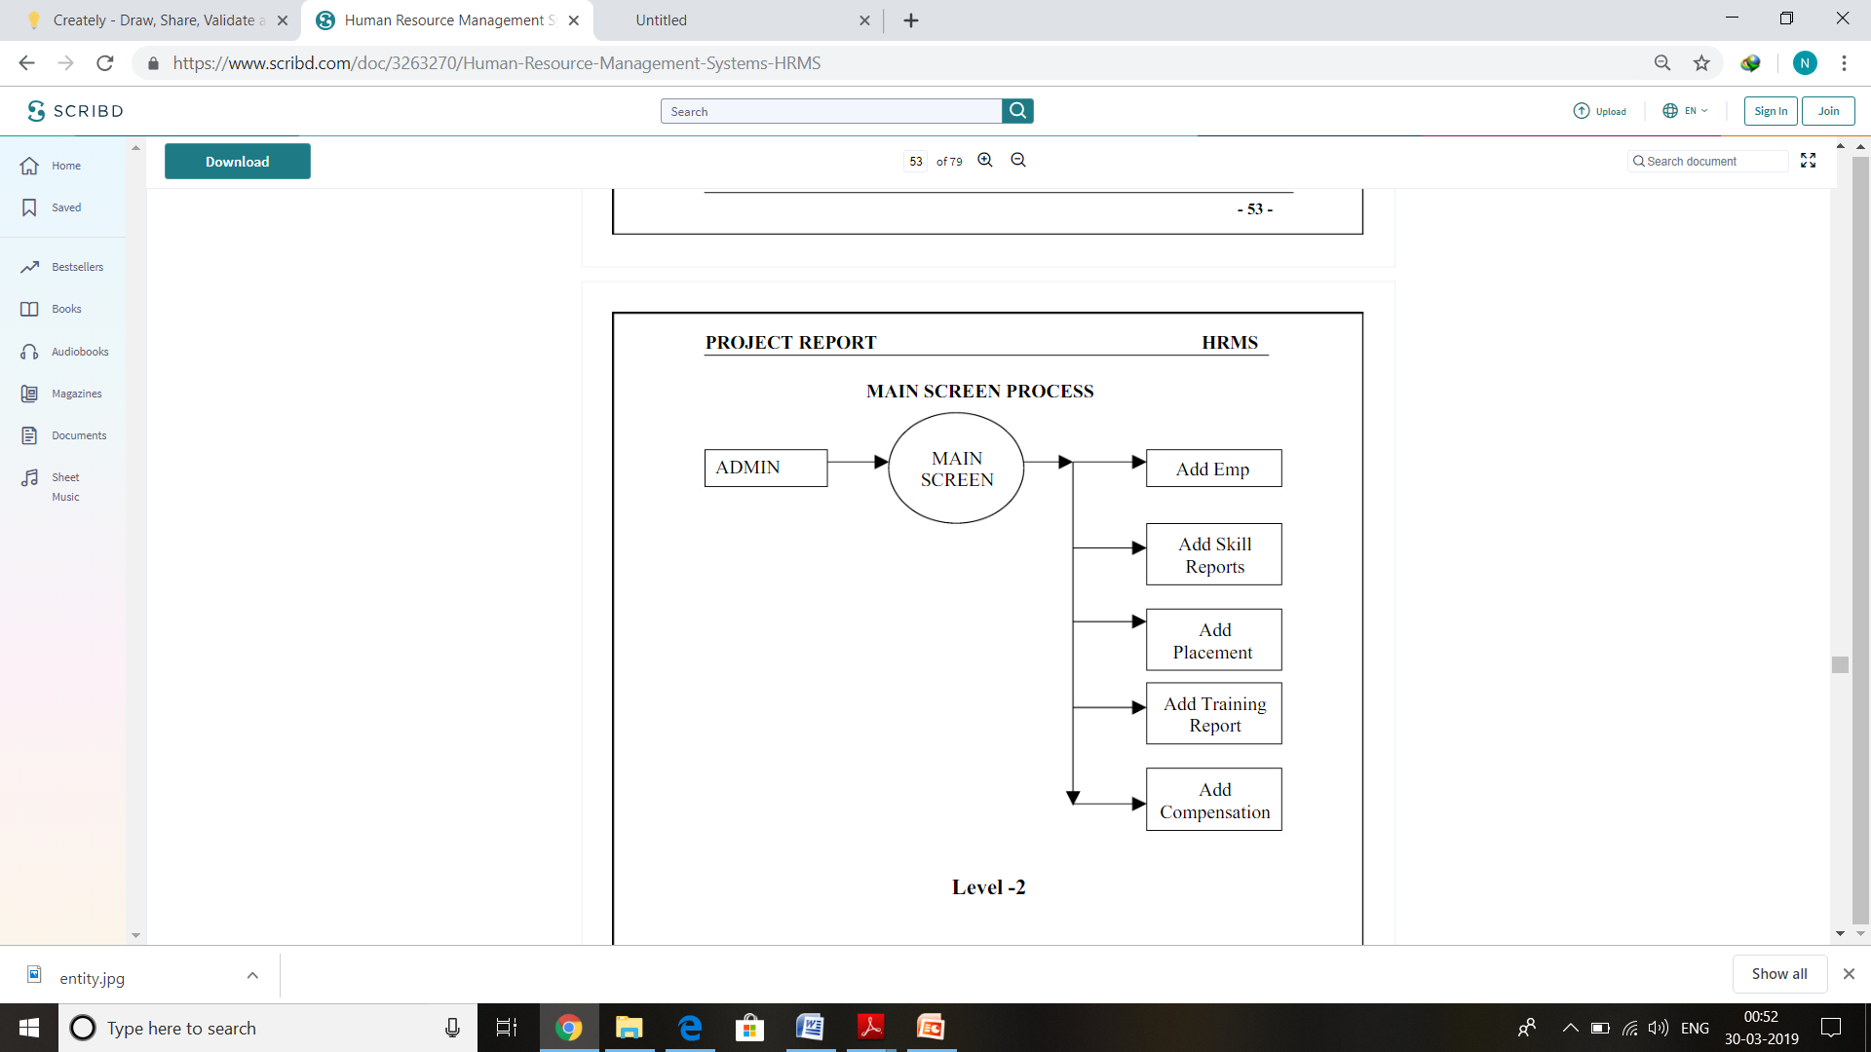

Figure 6.3.1: Low-level DFD

**14**

**6.3.3 Detailed Data Flow Diagrams**

1. Detailed DFD for user authentication

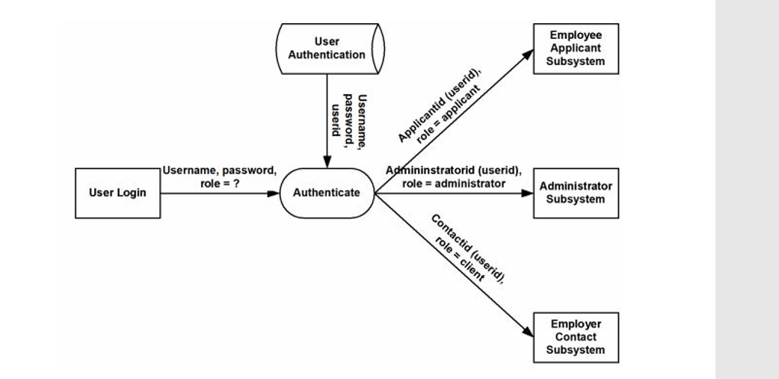

Figure 6.3.2: User Authentication

1. Detailed DFD for Employee Applicant update profile process

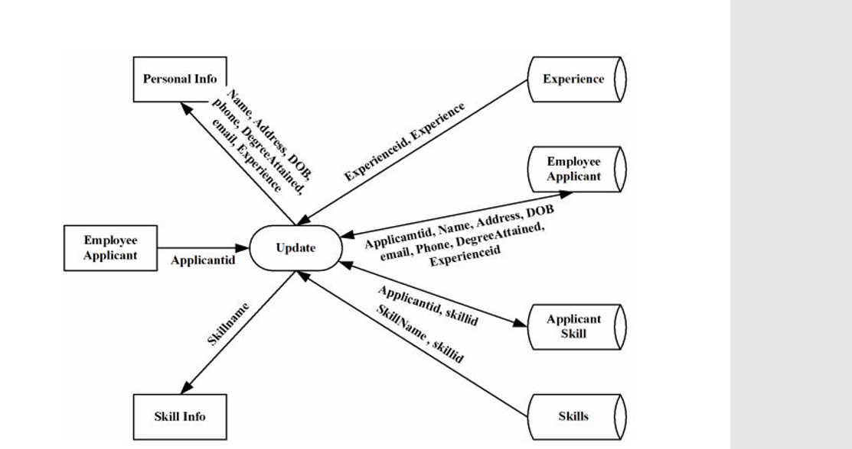

Figure 6.3.3: DFD for Employee Applicant update profile process

**15**

1. Detailed DFD for recruiting application

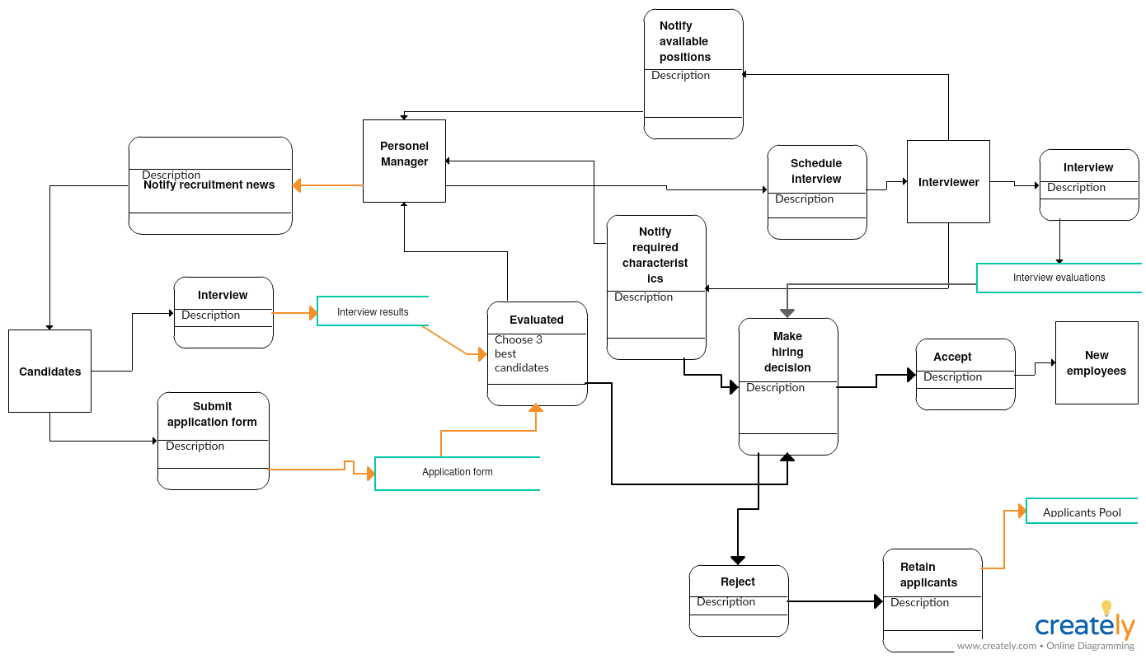

Figure 6.3.4:Detailed DFD for Recruitment process

**16**

**6.4 DATABASE DESIGN**

A Database in Salesforce is defined as the organized collection of objects where each object contains some information. Data is stored in the form of database tables for people, things, contacts etc that are important for any project in the future. Each database has a set of certain rows and columns where information is stored in the form of fields and records.

### ****How are Database Relations defined in the Salesforce?****

Relationships in Salesforce are used to connect different objects together. There are multiple relationships that could be defined for the Salesforce on the child object. The child object could have complete access to the object defined in the parent section based on the relationship and permissions defined.

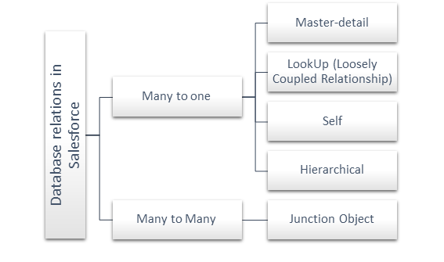

Figure 6.4: Database relations in Salesforce

**Many to one (n: 1)**

In this type of relationship, there is only one parent object and multiple child objects. For example, there are a number of metro cities in a country. It is further divided into two major categories as shown above in the hierarchy diagram –

1. Master-detail
2. Look Up (Loosely Coupled Relationship)

**17**

**Master-Detail relationships**

Here, we have one parent object and multiple child objects. For this type of relationship, you need to keep the following facts in mind –

1. The child record will be deleted automatically, once the master record is deleted.
2. Every time you wanted to create a child object then the reference of the parent object is needed.
3. There are no separate permissions or security settings defined for the child object but they are automatically inherited by the parent object.
4. The owner settings are automatically assigned to associated master objects.
5. On the page layout, there is a master-detail relationship is defined for the object.
6. The administrator will decide either child objects should be represented within the parent object or not.

**Look up Relationship**

This is one more category of one-to-many relationship but two objects will not put any effect on deletion or security. In this case,

1. Child objects are also independent. If we are deleting the parent object then child object will not get deleted.
2. The separate settings could be defined for the child object.
3. If we will delete the parent object then the child object would still remain into the system.
4. In this case, the child object may or may not have a parent.

**18**

**6.4.1 Table Design**

**Position Table**

|  |  |  |
| --- | --- | --- |
| Field name | Datatype | Description |
| Apex__c | Checkbox | Choice of language to potential candidate. |
| Approval_Status_c | Picklist | Acknowledges the candidates of their approval |
| Close_Date_c | Date | Closing date of job position |
| Open_Date­­_c | Date | Opening date of job position |
| Created_by_c | Lookup(user) | Job position created by |
| Type__c | Picklist | Type of job |
| Location­­__c | Picklist | Location of job |
| Hiring_Manager_c | Text(50) | Specifies the hiring manager |
| Max_Salary_c | Currency(18,0) | Maximum salary offered |
| Key_Responsibilities_c | Long Text Area(32768) | Responsibilities that an employee must adhere to |
| Department­­__c | Picklist | Particular Department for which job is present |
| Description__c | Long Text Area(32768) | Job description |
| Status__c | Picklist | Current status of employee |
| Functional_Areas_c | Picklist | Functional areas of employee |

Table 1: Position Module Table

**Candidate table**

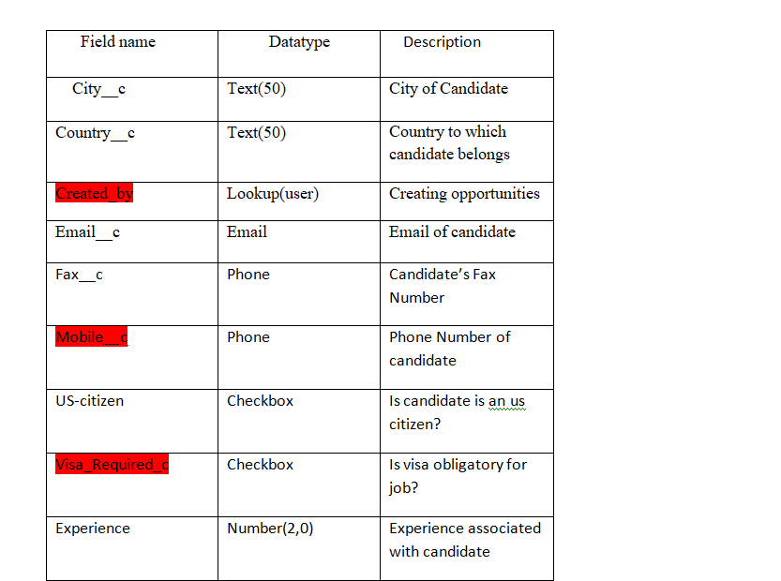

Table 2: Candidate Module Table

**20**

**Interviewer Module Table**

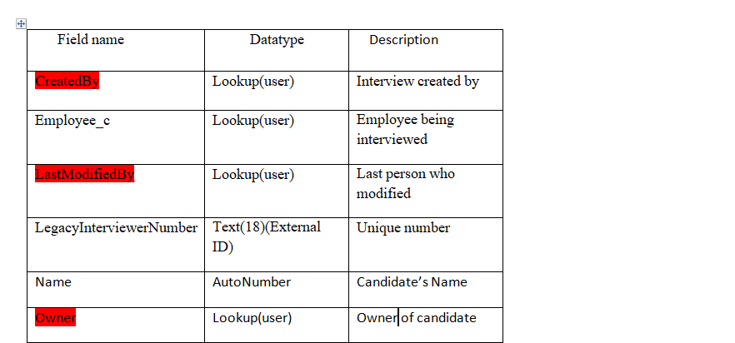

Table 3: Interviewer table

**21**

**Job Application Table**

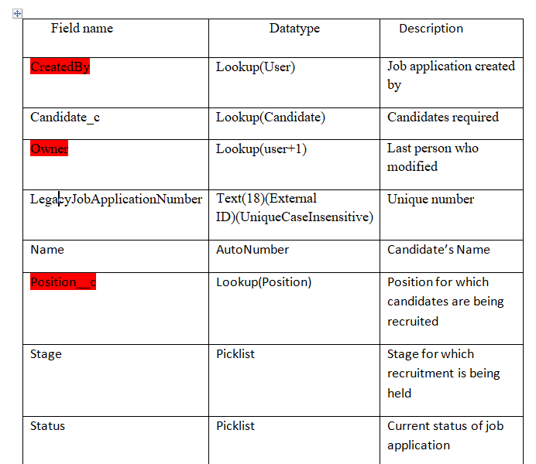

Table 4 : Job Application Module Table

22

**Job Posting Table**

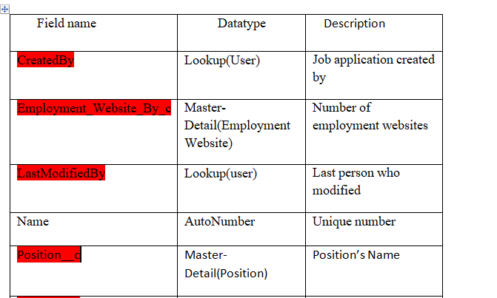

Table 5 : Job Posting Module Table

**23**

**Employment Website**

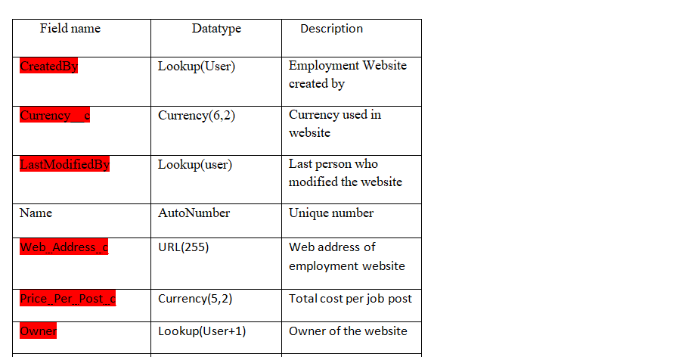

Table 6: Employment Website Module Table

**24**

**6.4.2 Relation Design**

There are 2 types of relationships in Salesforce:

**Master-Detail relationships**

Here, we have one parent object and multiple child objects. For this type of relationship, you need to keep the following facts in mind –

1. The child record will be deleted automatically, once the master record is deleted.
2. Every time you wanted to create a child object then the reference of the parent object is needed.
3. There are no separate permissions or security settings defined for the child object but they are automatically inherited by the parent object.
4. The owner settings are automatically assigned to associated master objects.
5. On the page layout, there is a master-detail relationship is defined for the object.
6. The administrator will decide either child objects should be represented within the parent object or not.

**Look up Relationship**

This is one more category of one-to-many relationship but two objects will not put any effect on deletion or security. In this case,

1. Child objects are also independent. If we are deleting the parent object then child object will not get deleted.
2. The separate settings could be defined for the child object.
3. If we will delete the parent object then the child object would still remain into the system.
4. In this case, the child object may or may not have a parent.

**25**

**Relation between Position, Candidate and Job Application Modules**

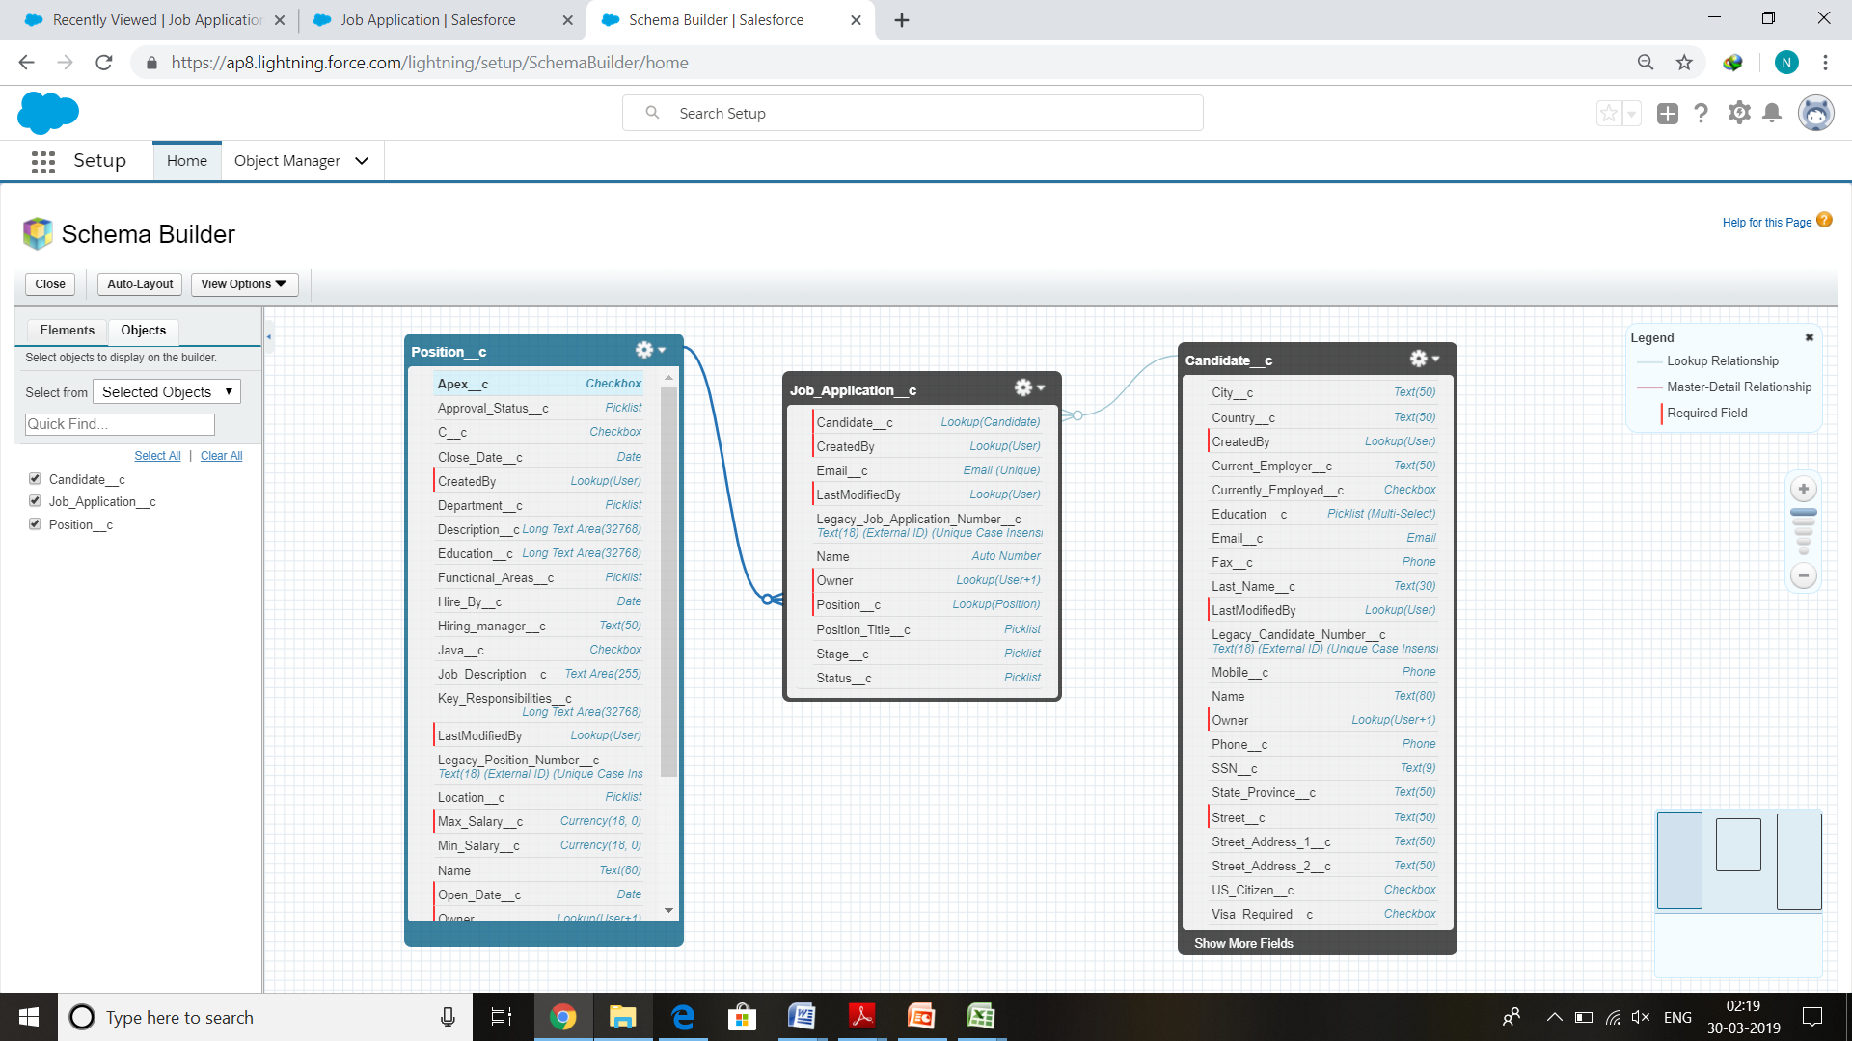

**Figure 6.4.2.1:** Relationship between Position, Candidate and Job Application Modules using Schema Builder

**Relation between Review and Job Application Modules**

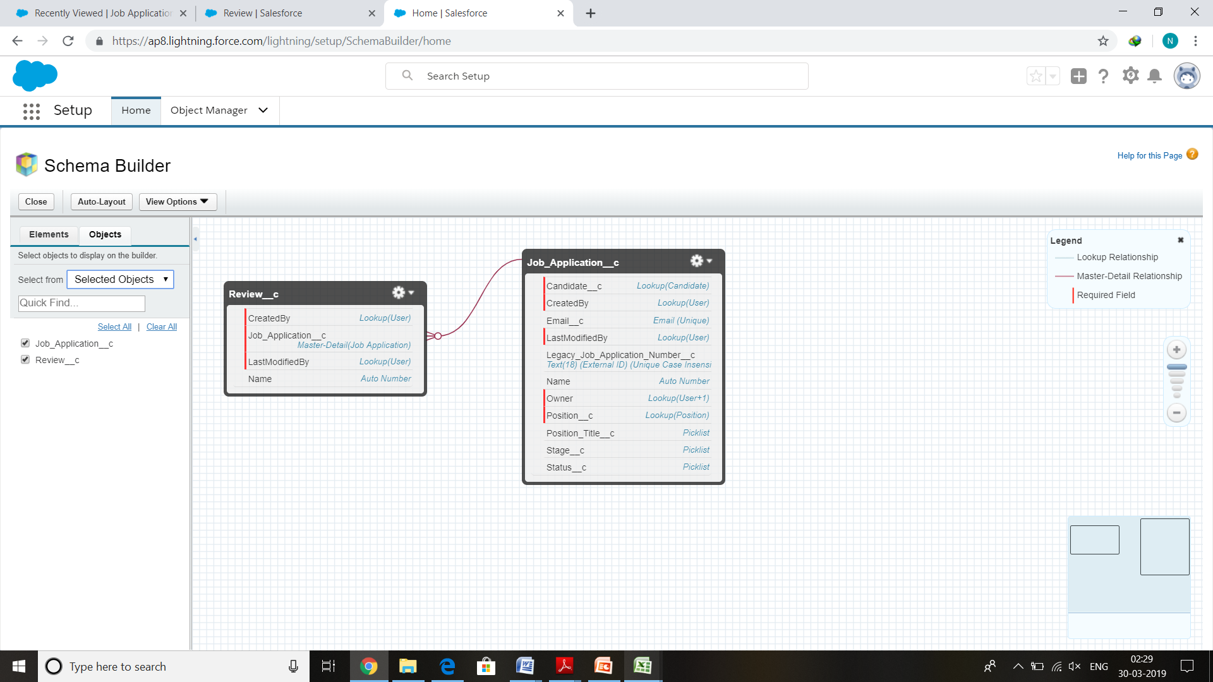

**Figure 6.4.2.2:** Relationship between Review and Job Application Modules using Schema Builder

**26**

**Relation between Position , Job Posting & Employment Website** 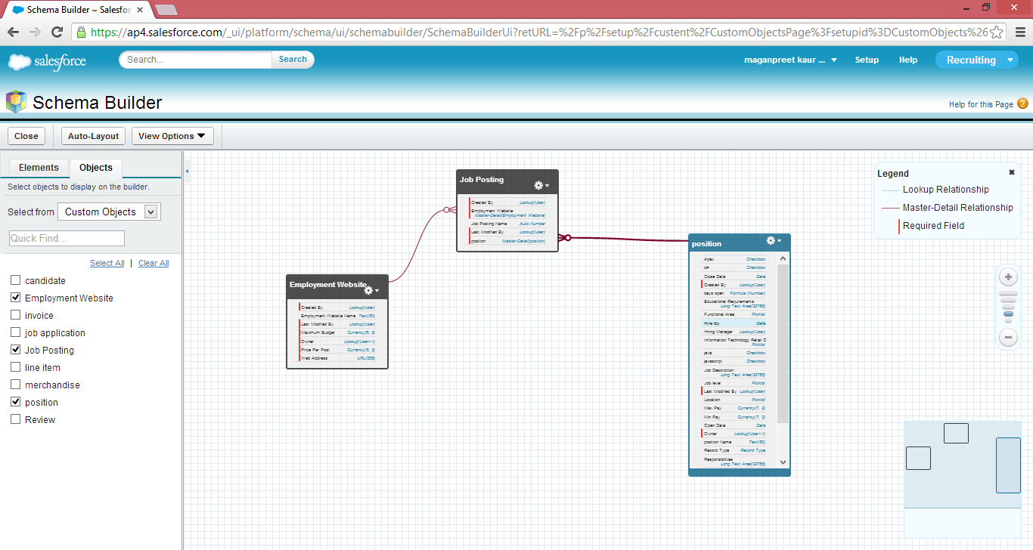

**Figure 6.4.2.3:** Relationship between Position , Job Posting & Employment Website using Schema builder

**27**

**6.4.3 Entity Relationship Diagram**

An entity relationship diagram (ERD) is a conceptual representation of structured data, and is especially useful for planning and understanding an app.



Figure 6.4.4: ER Diagram showing entities and relationships among them

**28**

**6.5 INTERFACE DESIGN**

Recruitment application is developed for HR to conduct recruitment process and assign the positions to selected candidates. This application provides HR to store and manage data of students and conduct the interview process very easily and smoothly. There is no need to make extra sheets, to store the details of the candidates. This application provides you to store all the data of candidates on cloud storage.This application works on 5 layer model of cloud which are defined as follows**:**

1. **Cloud Application Layer** ­ Cloud application layer provides the most visible layer to the end users of the cloud. Recruitment application provides an user interface to interact with users.
2. **Cloud Software Environment Layer ­** The cloud software environment layer(also dubbed the software platform layer). The users of this layer are cloud applications’ developers, implementing their applications for and deploying them on the cloud.In Recruitment application Force.com is an application development environment.
3. **Cloud Software Infrastructure Layer -** The cloud software infrastructure layer provides fundamental resources to other higher-level layers. Cloud services offered in this layer can be categorized into: computational resources, data storage, and communications. In Recruitment application Salesforce manage in infrastructure of auto scaling and load balancing on basis of number of working users.
4. **Software Kernel** ­ This cloud layer provides the basic software management for   the physical servers that compose the cloud. Software kernels at this level can be   implemented as an OS kernel, hypervisor, and virtual machine monitor and/or clustering middleware.
5. **Hardware and Firmware​ ­** The bottom layer of the cloud stack in our proposed ontology is the actual physical hardware and switches that form the backbone of the cloud. In this regard, users of this layer of the cloud are normally big   enterprises with huge IT requirements in need of subleasing Hardware as a Service (HaaS).

**29**

**6.5.1 Input Design**

The input design is the link between the information system and the user. It comprises the developing specification and procedures for data preparation and those steps are necessary to put transaction data in to a usable form for processing can be achieved by inspecting the computer to read data from a written or printed document or it can occur by having people keying the data directly into the system. The design of input focuses on controlling the amount of input required, controlling the errors, avoiding delay, avoiding extra steps and keeping the process simple. The input is designed in such a way so that it provides security and ease of use with retaining the privacy. Input Design considered the following things:

1. What data should be given as input?
2. How the data should be arranged or coded?
3. The dialog to guide the operating personnel in providing input.
4. Methods for preparing input validations and steps to follow when error occur.

**6.5.1.1 REGISTER AT SALESFORCE**

Salesforce provides a register page for registration. User need to enter basic information        and a username and password, after registration you are allowed to enter into applications domain. Now you are able to install Salesforce apps from App exchange. Although you can browse the application from appexchange.salesforce.com.

**30**

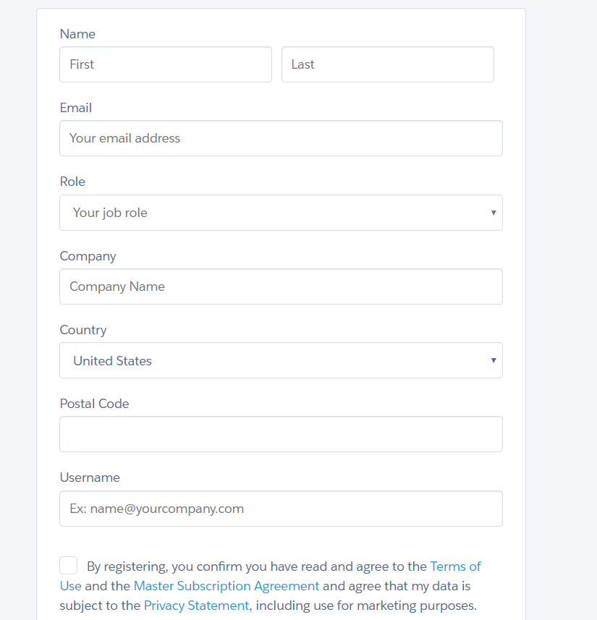

Figure 6.5.1.1 Sign-Up Form

**31**

**6.5.1.2 LOGIN TO SALESFORCE**

After Registration user can login to Salesforce application environment by providing             username and password. The Login Page as follows ­

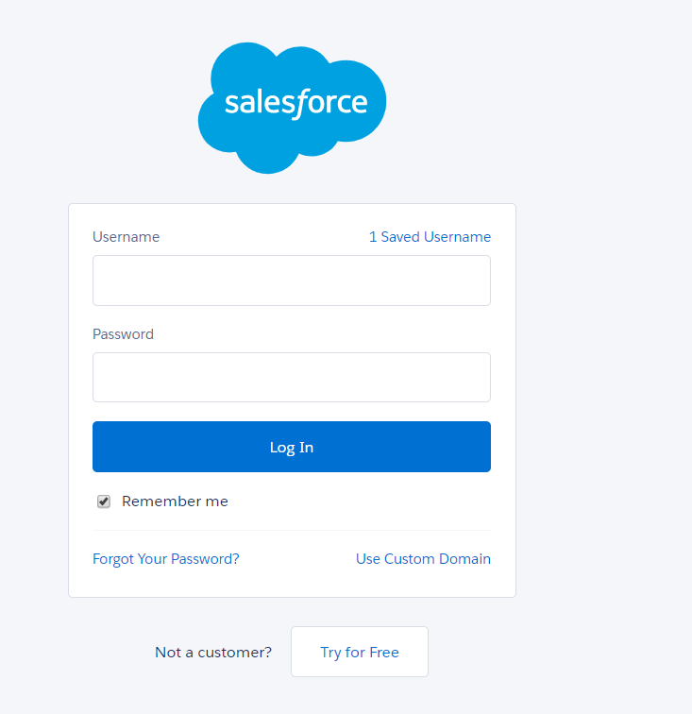

Figure 6.5.1.2 Login Page

**32**

**6.5.2 Output Design**

**6.5.2.1 HOME PAGE**

Home page consists of 10 tabs-Positions, Candidates, Job opportunities, Interviewers, Employment Websites, Job position, Chatter, Reports & Dashboards.

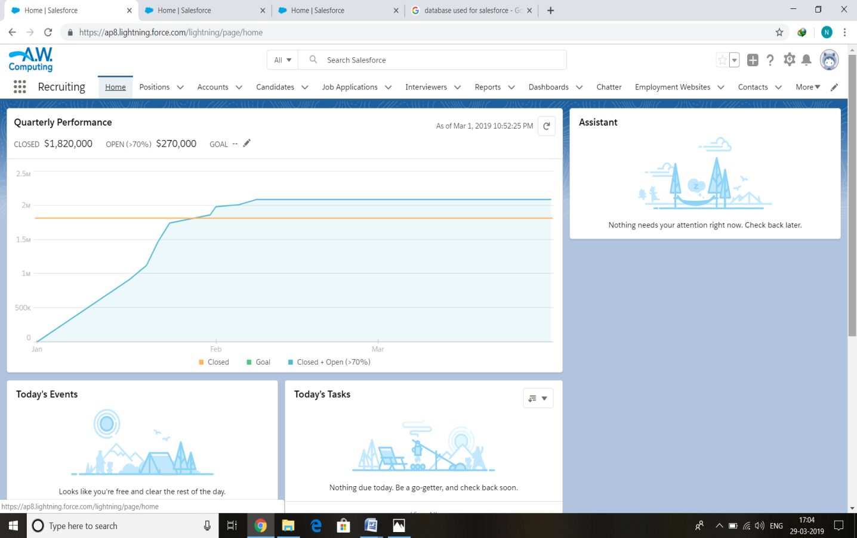

Figure 6.5.2.1: Home page

**33**

**7. Implementation**

**7.1 Login into Salesforce Account**



Figure 7.1 Log In Page

**34**

**7.2** Home Tab



Figure 7.2.1: Home Page after Login

7.3 Position Tab

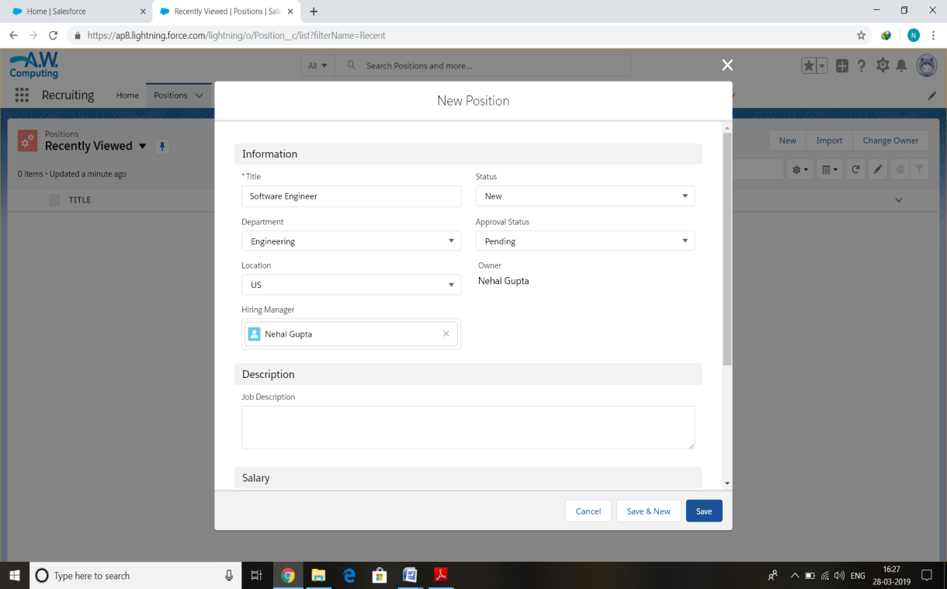

Figure 7.3: Position Tab Contents

**35**

7.3.1 Position Database

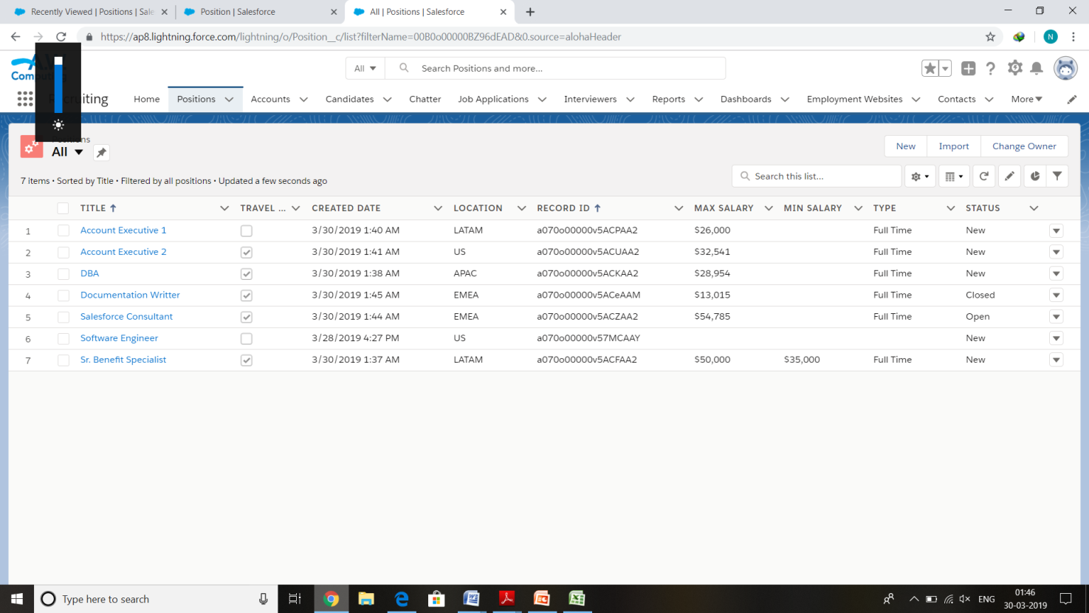

Figure 7.3.1 Position Database showing all available positions

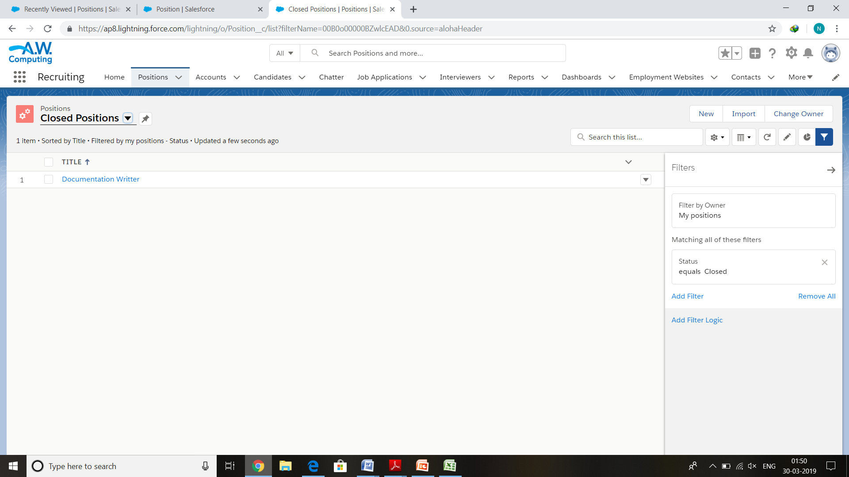

Figure 7.3.2: Position Database showing only closed positions

**36**

7.4 Candidate Tab

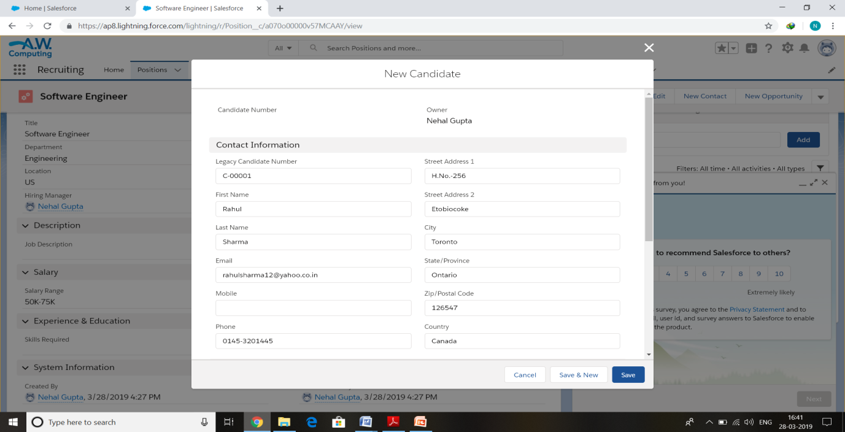

Figure 7.4.1 Candidate Tab Contents

7.5 Candidate Database

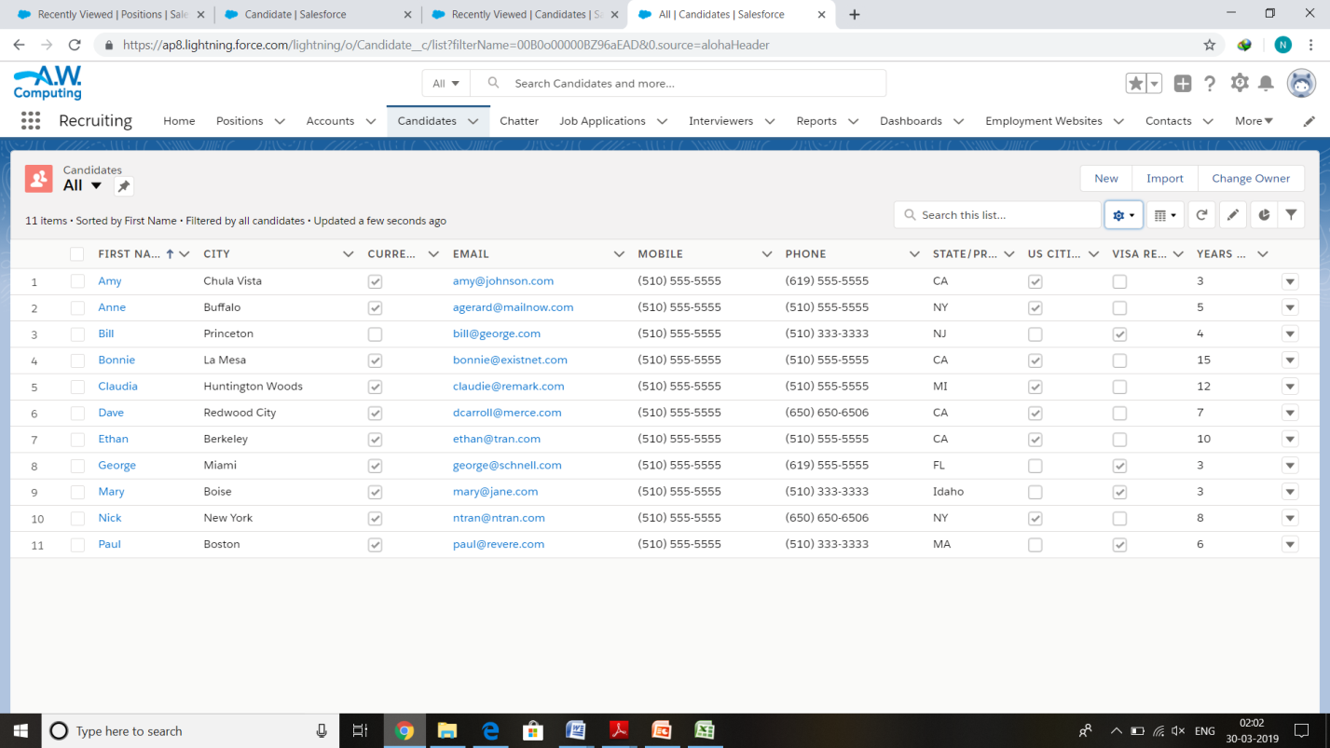

Figure 7.5.1 Database of Candidate object

7.6 Job Application Tab

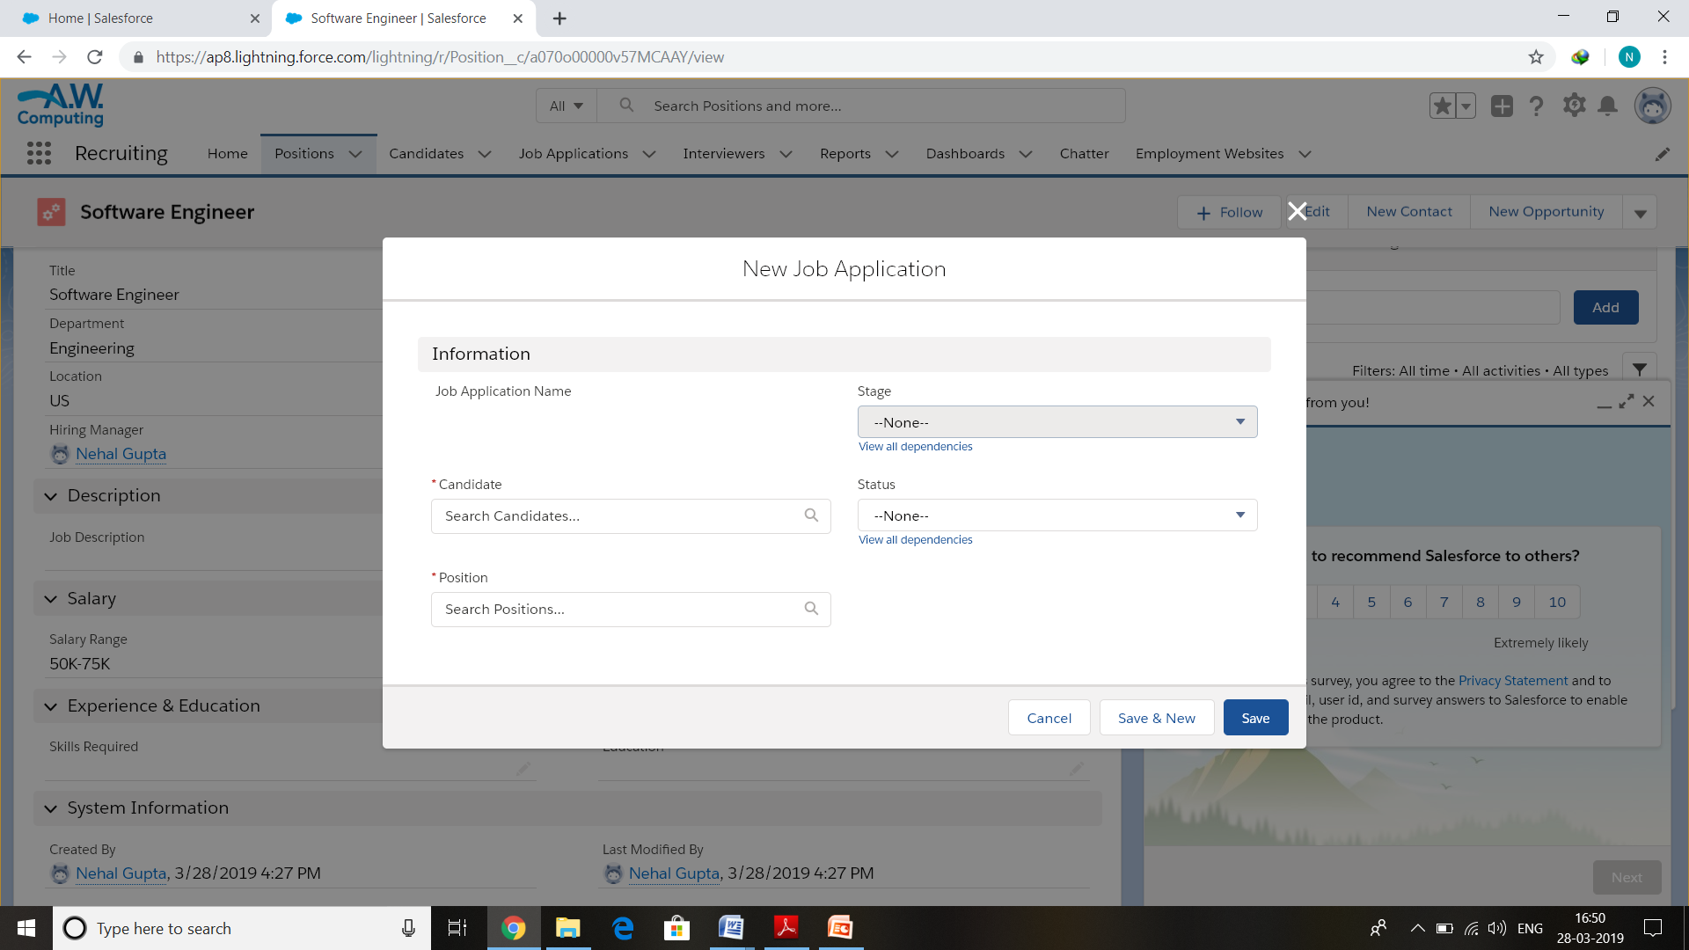

Figure 7.6.1 Job application Module

7.7 Database of Job Application

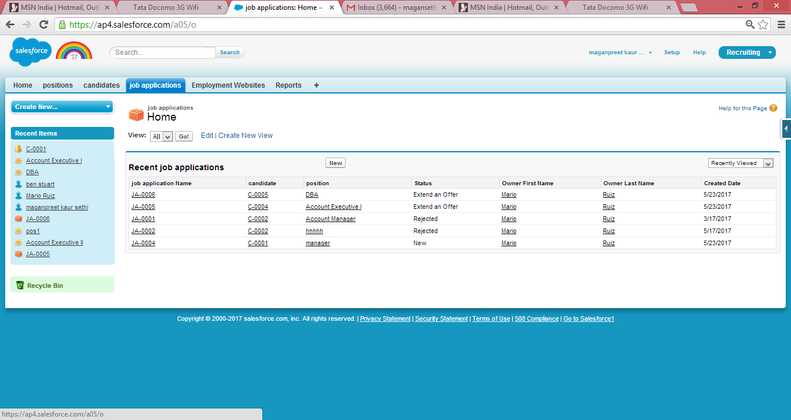

Figure 7.7.1 Database of Job Application

**38**

7.8 Account Module

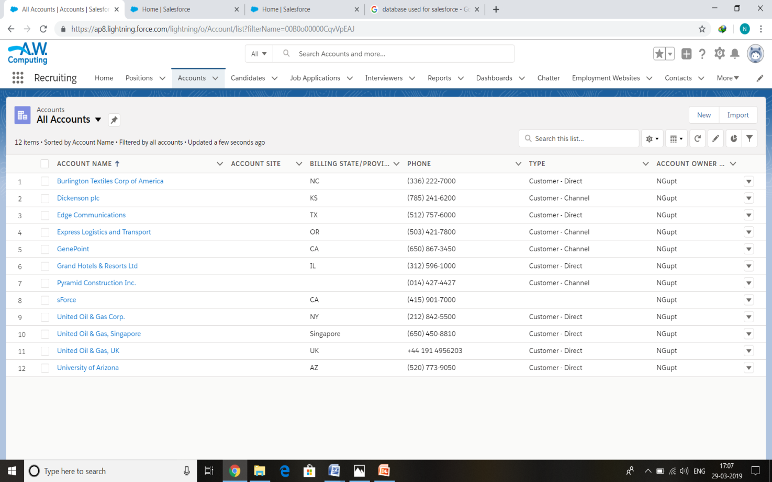

Figure 7.8.1 Database of Account Module

7.9 Employment Website

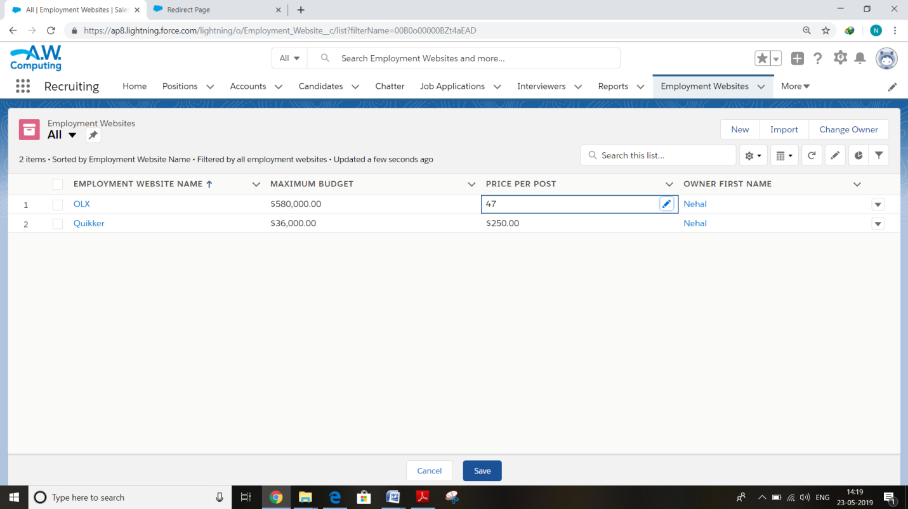

Figure 7.9.1 Employment Websites

**39**

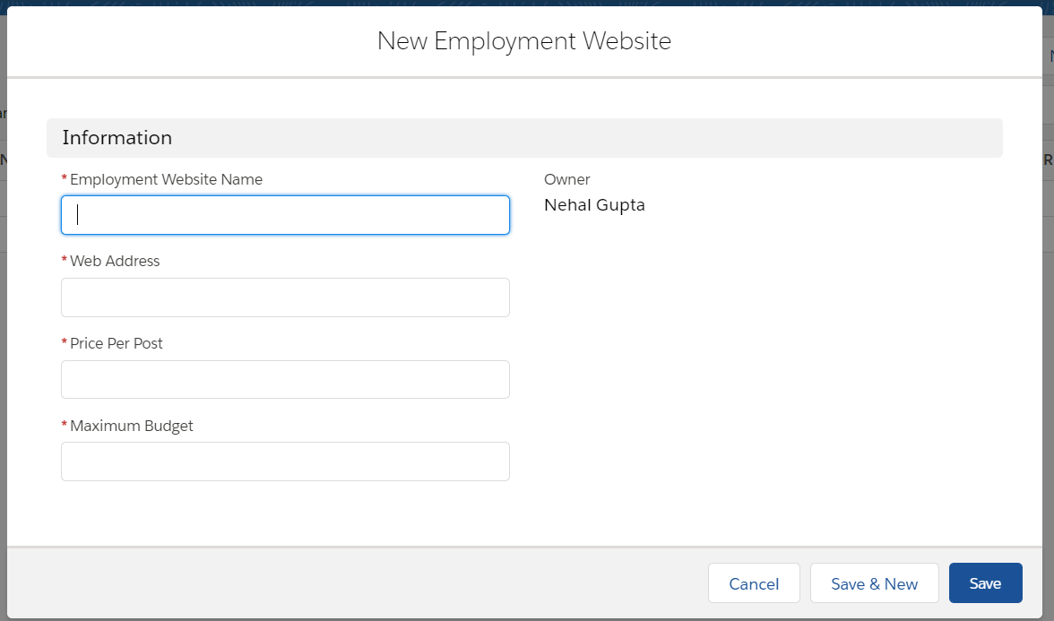

Figure 7.9.2 Employment Website Module

7.10 Chatter

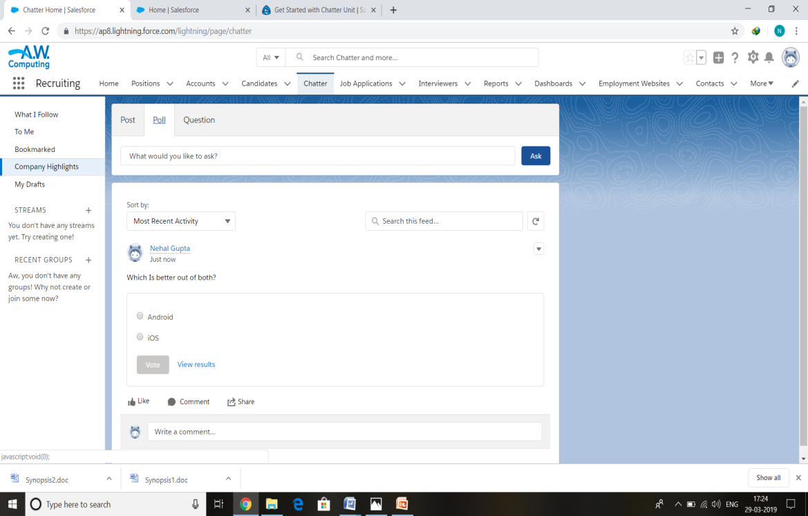

Figure 7.10.1 Chatter Module

**40**

7.11 Reports

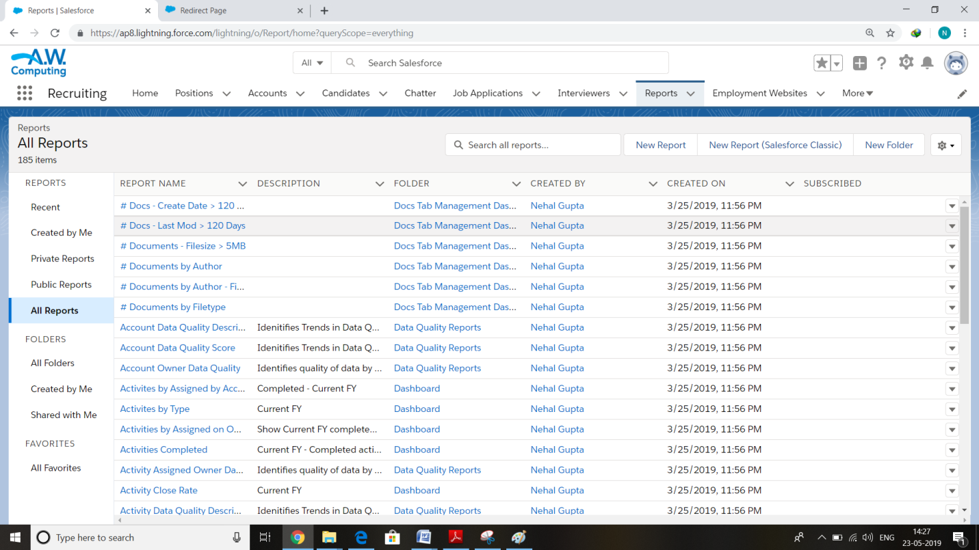

Figure 7.11.1 Reports

7.12 Users

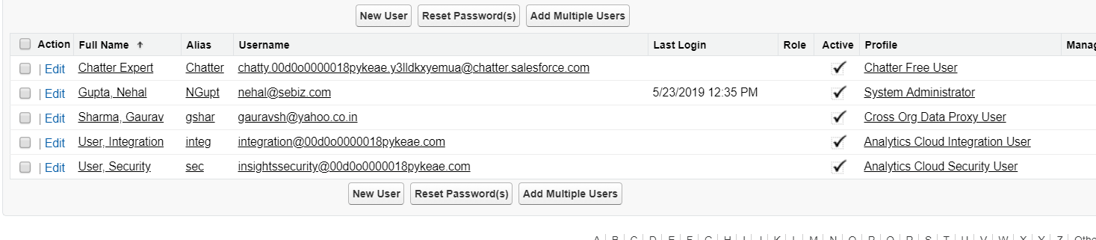

Figure 7.12.1 List of users

**41**

**8. Testing**

The Force.com platform requires that at least 75% of the Apex Code in an org be    executed via unit tests in order to deploy the code to production. You shouldn’t consider 75% code coverage to be an end goal though. Instead, you should strive to increase the state coverage of your unit tests. Code has many more possible states than it has lines of  code . For  example, the following  method  has  4,294,967,296 different states:

System testing of software or hardware is testing conducted on a complete, integrated system to evaluate the system's compliance with its specified requirements. System testing falls within the scope of black box testing, and as such, should require no knowledge of the inner design of the code or logic.

**Software testing** is a process, to evaluate the functionality of a software application with an intent to find whether the developed software met the specified requirements or not and to identify the defects to ensure that the product is defect free in order to produce the quality product. Software testing can be stated as the process of verifying and validating that a software or application is bug free, meets the technical requirements as guided by it’s design and development and meets the user requirements effectively and efficiently with handling all the exceptional and boundary cases.

The process of software testing aims not only at finding faults in the existing software but also at finding measures to improve the software in terms of efficiency, accuracy and usability. It mainly aims at measuring specification, functionality and performance of a software program or application.

**8.1 Objectives of Software Testing**

The software testing is usually performed for the following objectives:

1. [Finding defects](http://tryqa.com/what-is-defect-or-bugs-or-faults-in-software-testing/) which may get created by the programmer while developing the software.
2. Gaining confidence in and providing information about the level of [quality](http://tryqa.com/what-is-software-quality/).
3. To prevent defects.
4. To make sure that the end result meets the business and user requirements.
5. To ensure that it satisfies the BRS that is Business Requirement Specification and SRS that is System Requirement Specifications.
6. To gain the confidence of the customers by providing them a quality product.

**8.2 Principles of Software Testing**

1. All tests should be traceable to customer requirements.
2. Use effective resources to test.
3. It is impossible to test everything.
4. Document test cases and test results.
5. Keep software static during testing.
6. Testing time and resources should be limited.

**42**

**8.3 White-box Testing**

**WHITE BOX TESTING**(also known as Clear Box Testing, Open Box Testing, Glass Box Testing, Transparent Box Testing, Code-Based Testing or Structural Testing) is a [software testing method](http://softwaretestingfundamentals.com/software-testing-methods/) in which the internal structure/design/implementation of the item being tested is known to the tester. The tester chooses inputs to exercise paths through the code and determines the appropriate outputs. Programming know-how and the implementation knowledge is essential. White box testing is testing beyond the user interface and into the nitty-gritty of a system. White box testing is the detailed investigation of internal logic and structure of the code.  White box testing is also called glass testing or open box testing. In order to perform   white box testing on an application, a tester needs to know the internal workings of the code.

**8.4 Black-box Testing**

The technique of testing without having any knowledge of the interior workings of the application is called black box testing. The tester is oblivious to the system architecture and does not have access to the source code. Typically, while performing a black box test, a tester will interact with the system's user interface by providing inputs and  examining outputs without knowing how and where the inputs are worked upon.

**8.5 Grey-box Testing**

Grey­box testing is a technique to test the application with having a limited knowledge of the internal workings of an application. In software testing, the phrase the phrase the more you know the better carries a lot of weight while testing an application.

**8.6 Testing Strategies**

**8.6.1 Unit Testing**

**UNIT TESTING** is a level of software testing where individual units/ components of a software are tested. The purpose is to validate that each unit of the software performs as designed. A unit is the smallest testable part of any software. It usually has one or a few inputs and usually a single output. In procedural programming, a unit may be an individual program, function, procedure, etc. In object-oriented programming, the smallest unit is a method, which may belong to a base/ super class, abstract class or derived/ child class. (Some treat a module of an application as a unit. This is to be discouraged as there will probably be many individual units within that module.) Unit testing frameworks, drivers, stubs, and mock/ fake objects are used to assist in unit testing.

**43**

**8.6.2 Integration Testing**

**INTEGRATION TESTING** is a level of software testing where individual units are combined and tested as a group. The purpose of this level of testing is to expose faults in the interaction between integrated units. Test drivers and test stubs are used to assist in Integration Testing. *Big Bang* is an approach to Integration Testing where all or most of the units are combined together and tested at one go. This approach is taken when the testing team receives the entire software in a bundle. So what is the difference between Big Bang Integration Testing and System Testing? Well, the former tests only the interactions between the units while the latter tests the entire system.

**8.6.3 System Testing**

**SYSTEM TESTING**is a level of software testing where a complete and integrated software is tested. The purpose of this test is to evaluate the system’s compliance with the specified requirements. System Testing is the testing of a complete and fully integrated software product. Usually, software is only one element of a larger computer-based system. Ultimately, software is interfaced with other software/hardware systems. System Testing is actually a series of different tests whose sole purpose is to exercise the full computer-based system.

**8.6.4 Acceptance Testing**

**ACCEPTANCE TESTING**is a level of software testing where a system is tested for acceptability. The purpose of this test is to evaluate the system’s compliance with the business requirements and assess whether it is acceptable for delivery. Acceptance testing, a testing technique performed to determine whether or not the software system has met the requirement specifications. The main purpose of this test is to evaluate the system's compliance with the business requirements and verify if it is has met the required criteria for delivery to end users.

In System Testing we have tested entire Recruitment Application. We have run all  programs as a single system and inputs various test cases and analyze that all are going correctly or not. In system testing we have tested various test cases. According to which, Application showed the corresponding error message.

**44**

**8.7 Test Cases**

1. **Test Case for Login**

If a user enters correct username and password, then he/she is logged in successfully. Else if, user has entered an incorrect username or password then an error message prompting user that “Your login has been unsuccessful, either your username or password is invalid”.

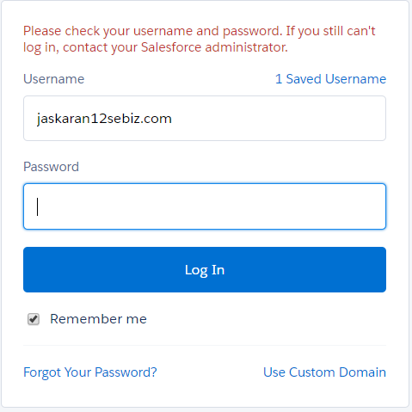

Figure 8.7.1 Invalid username password page

**45**

1. If while entering salary for a candidate, Min Pay exceeds Max Pay, Server will give an error message.

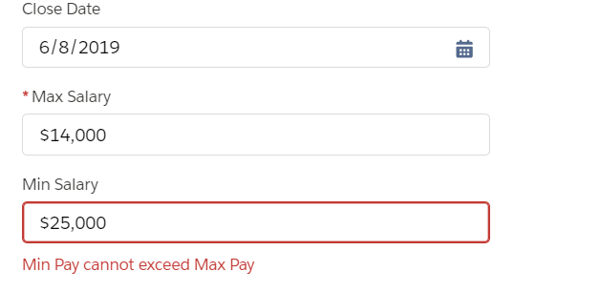

Figure 8.7.2: Min pay Greater than Max pay

1. If Email is not entered in ‘abc@xyz.com’ Format, it will display an error message saying ‘Invalid email address’.

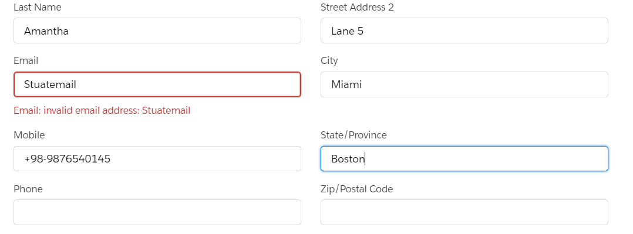

Figure 8.7.3 Email verification

**46**

1. If required fields that are fields with a asterisk (*) are not filled, it will display a prompt saying ‘Complete this field: Field name’

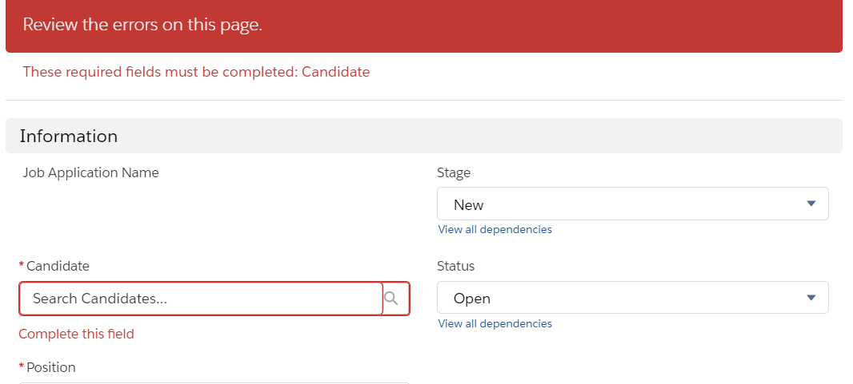

Figure: 8.7.4 Required Field Test case

**47**

**9. Future Enhancements**

In Today’s Competitive business world, organizations are struggling to stand first and get more benefits. In India too, Information Technology is the one, which has held the first position for long years with many innovative trends. Today is an era of platform independent technology and because programming languages are becoming obsolete, Salesforce is one such platform that can become face of Information technology in coming years. Salesforce provides a code-free development environment. These new ways of building and running applications are enabled by the world of *cloud computing*, where you access applications, or *apps*, over the Internet as utilities, rather than as pieces of software running on your desktop or in the server room. This model is already quite common for consumer apps like email and photo sharing, and for certain business applications, like customer relationship management (CRM).

As users of the Internet, we're all familiar with the fascinating, innovative, creative, and sometimes silly ways in which it has changed how we work and play. From social networking sites to wikis to blogs, and more, it’s exciting to watch the innovations taking place that are changing the ways we communicate and collaborate. While these changes have certainly impacted how we work with content, a similar set of Internet-driven ideas and technologies is changing how we build and work with business applications. While yesterday's business applications required thousands, if not millions, of dollars and sometimes years of professional

services help to set up and customize, the technologies offered by the Internet today make it much easier to create, configure, and use business applications of all kinds. Indeed, the power of the Internet has given us the ability to solve new kinds of business problems that, because of complexity or cost, had previously remained out of reach.

Because almost all apps these days are delivered via a Web browser, it's increasingly hard to tell which applications are “traditional software,” and which are run in the cloud. As with the Internet, applications that run in the cloud have grown so ubiquitous that almost every business user interacts with at least one, whether it's an email service, a Web conferencing application, or a sales system.

This Project ‘Hr Recruitment App’ has a huge future scope as this is the combination of existing and non existing recruitment system it has huge scope. It fulfils the requirement of every organization. This is a common platform both for applicant and HR to check the vacancies and fill those vacancies with best suitable candidate.

There is no denial to the fact that Salesforce is the most fascinating thing happened to IT industry across the globe. Similar to traditional platforms, cloud computing platforms provide tools that allow developers to leverage existing functionality to create something new; however, because these platform tools are accessed freely over the Internet rather than through an operating system or package that was installed on a local machine, developers don't need to worry about the logistics of putting together an executable that will be installed on a user's machine. Anyone with a Web browser can access the app!

**48**

While these changes have certainly impacted how we work with content, a similar set of Internet-driven ideas and technologies is changing how we build and work with business applications. While yesterday's business applications required thousands, if not millions, of dollars and sometimes years of professional services help to set up and customize, the technologies offered by the Internet today make it much easier to create, configure, and use business applications of all kinds.

Indeed, the power of the Internet has given us the ability to solve new kinds of business problems that, because of complexity or cost, had previously remained out of reach. The best part about Salesforce and clout computing is that its ecosystem is self-sustaining from mobility to middleware, it is impacting everything and will continue to make a big and magnanimous impact in future too.

**49**

**10. Bibliography**

1. [**www.developer.salesforce.com**](http://www.developer.salesforce.com)
2. [**www.trailhead.salesforce.com**](http://www.trailhead.salesforce.com)

**50**